

Carbon PRO Report

Environmental Planting

Somewhere, VIC

12March 2025

# Overview

This section provides an overview of the property and carbon assessment.

## Preview

Table . Summary of Assessment

|  |  |
| --- | --- |
| Item assessed | Assessment |
| Planting Area | **Moderate risk.** Lots of risk. |
| Carbon returns | **High risk.** Only 4.1 ACCUs/ha. |
| Topography | **Low risk.** Little to no areas with slope greater than 15 degrees. |

Located in the Dandenong ranges surrounded by wet sclerophyll forests and carbon rich soils.

Figure . Location within the region and state.

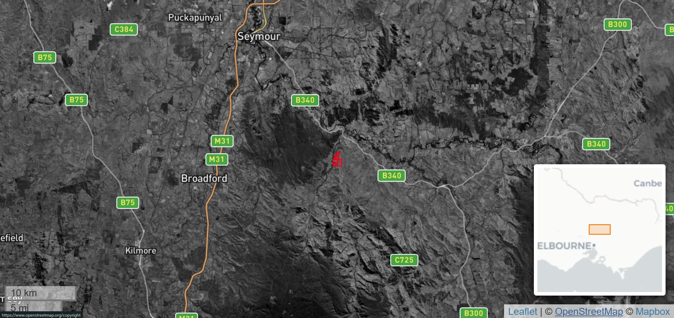

## Summary

Table . Somewhere summary

|  |  |
| --- | --- |
| **Attribute** | **Details** |
| Property Name | PROP-002194, King Parrot |
| Property Size | 172.94ha |
| Address / Location | Somewhere, VIC |
| LGA | Murrindindi |
| Planting Area | 52 ha |
| Ineligible Area[1] | 105 ha |
| Total ACCUs generated (gross) | 2500 ACCUs |
| Total ACCUs (net) - for 25 years* | 120210 ACCUs |
| Total ACCUs (net) - for 100 years** | 21021 ACCUs |
| Tenure | Freehold: 105ha  Other Crown Purposes: 50ha |
| Köppen Climate Classification | Temperate: no dry season (warm summer) |
| Average Rainfall | 704 mm (Appendix A, Figure A1) |
| Frost Potential | 10 days/year (Appendix A, Figure A3) |
| * Inclusive of 20% permanence period discount and 5% risk of reversal buffer  ** Inclusive of 5% risk of reversal buffer | |

# Carbon

This section presents a visual overview of the property-specific information to consider when determining the feasibility of developing an Environmental Planting (EP) project.

## Planting Area

The area that may be suitable for planting within your designated project area.

Figure 2. Boundary map of Somewhere property. Green polygons correspond to non-woody areas and pink polygons represent areas where ‘forest loss’ is likely to have occurred.

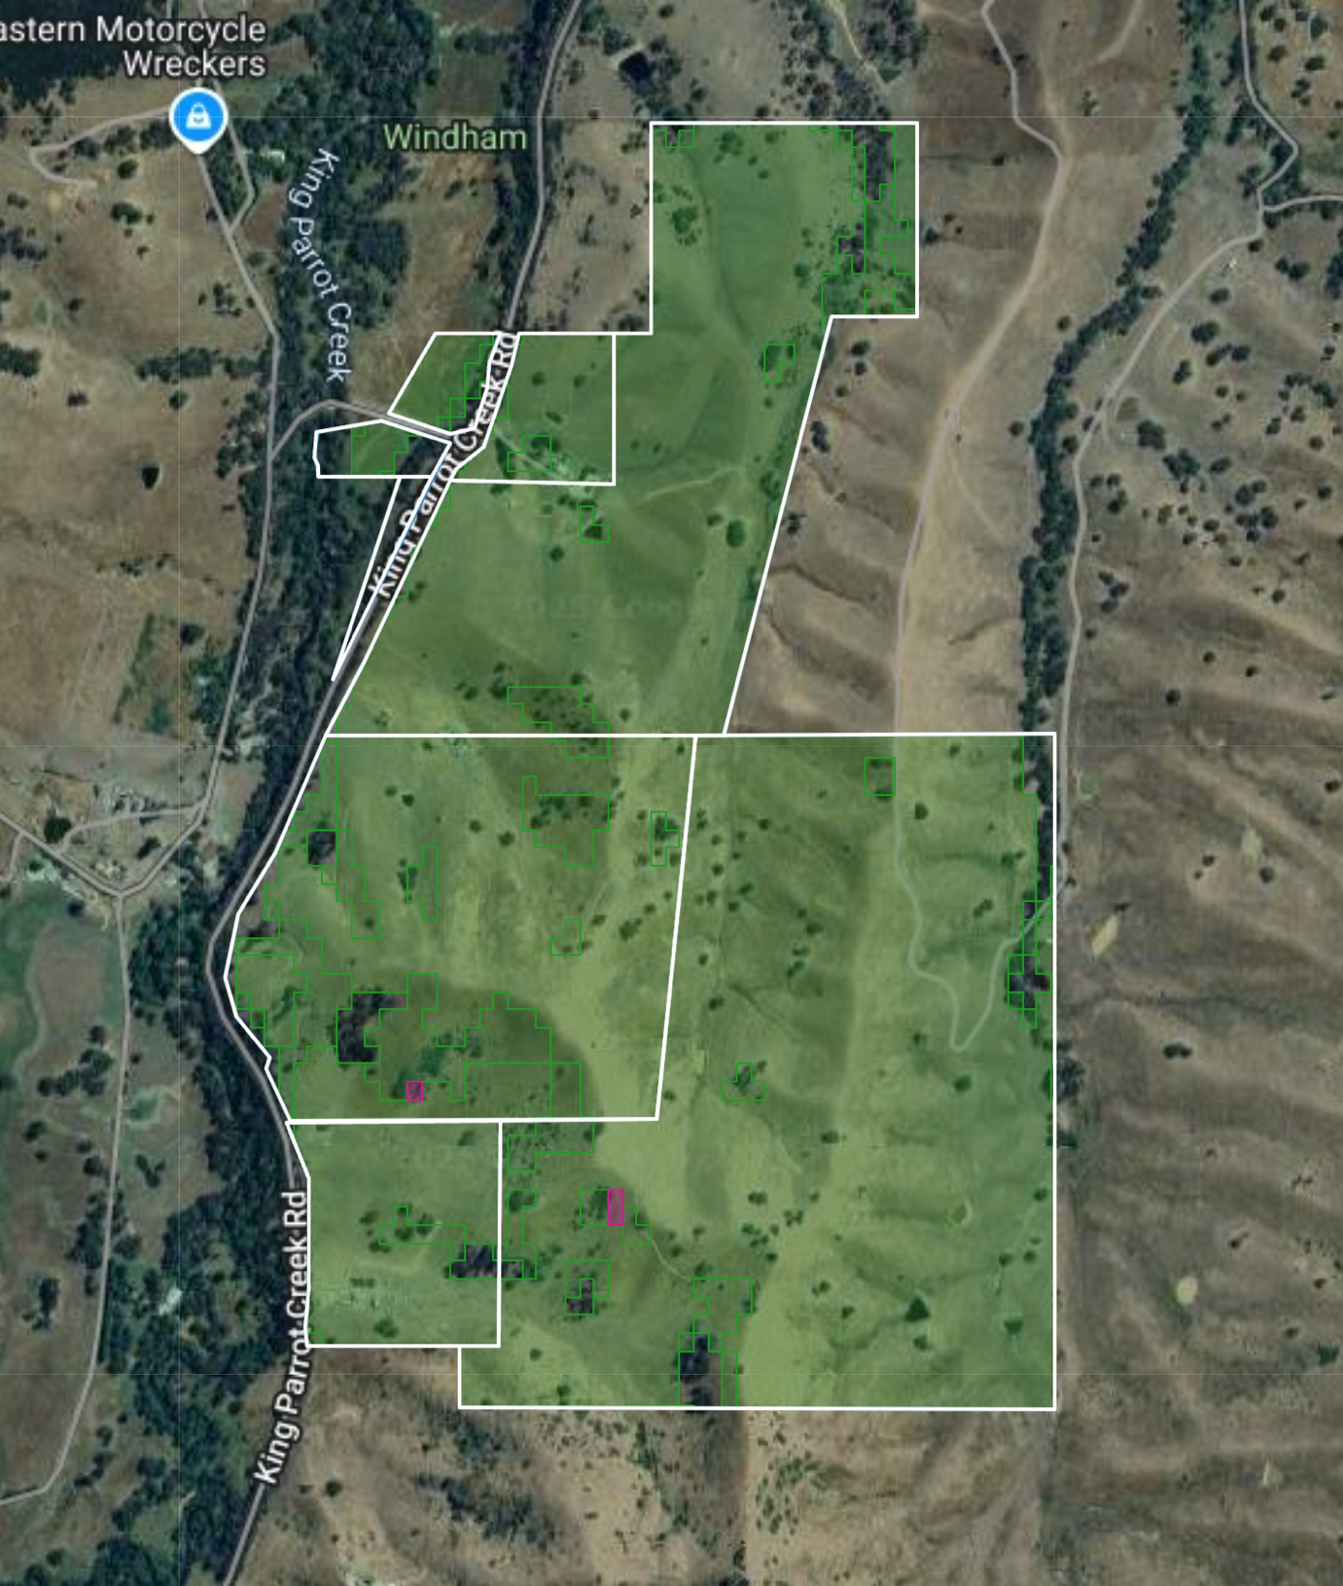

Table 3: Summary of the woody vegetation cover of Somewhere property estimated by grovia – National Forest and Sparse Woody Vegetation Data, 2023.

| **Category** | **Total Area (ha)** | **Percent Cover (%)** |
| --- | --- | --- |
| Non-woody (eligible) | 148.66 | 85.96 |
| Non-woody (ineligible)* | 0.31 | 0.18 |
| Sparse woody vegetation | 16.65 | 9.63 |
| Woody vegetation (forest) | 7.31 | 4.23 |
| Total | 172.93 | 100.00 |
| * The National Forest and Sparse Woody Vegetation data indicates that woody vegetation loss has likely occurred in the past 7 years. | | |

## Carbon assessment

Assessing carbon requires…

### Spatial distribution of carbon yield

A carbon heatmap visually represents the distribution and capacity of the land to store aboveground carbon. This allows you to review and optimise your planting area based on the potential carbon yield.

Figure 2: Carbon heatmap of Somewhere property.

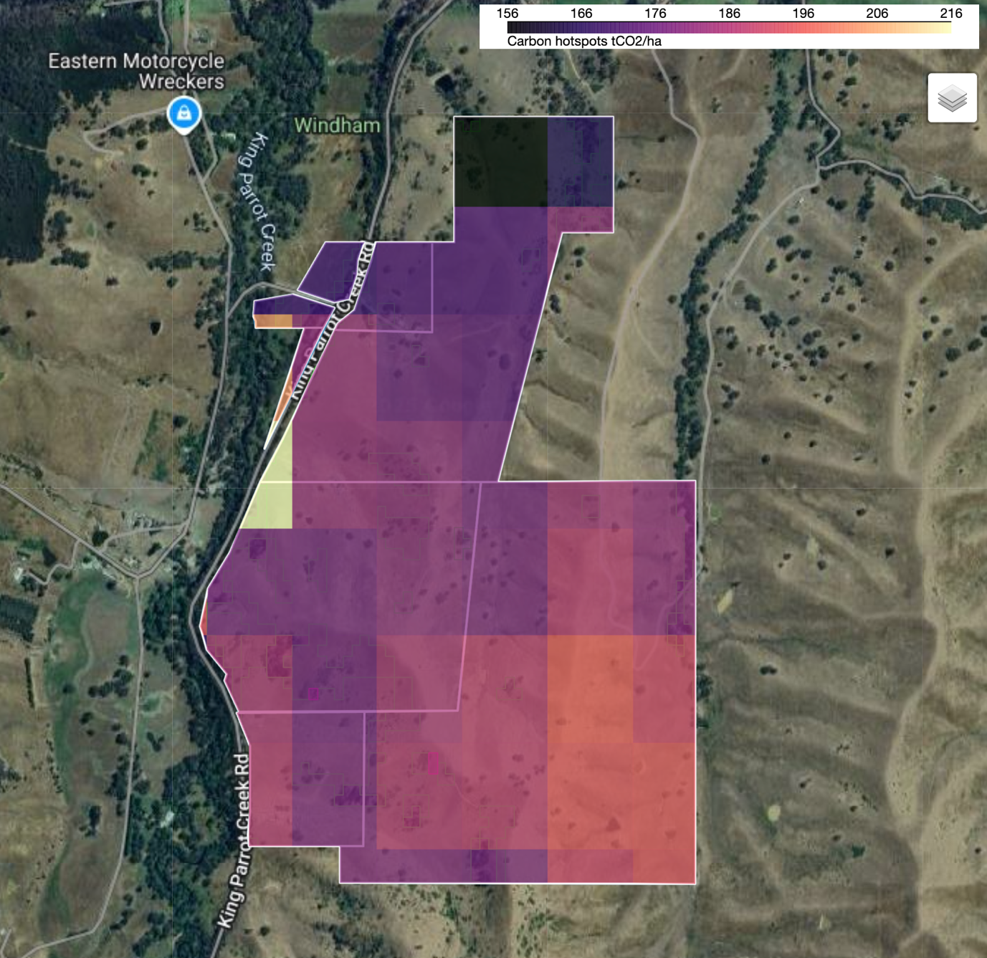

### Carbon credits

Carbon credits assessed using estimated CEAs.

Table . Carbon crediting details

|  |  |
| --- | --- |
| **Parameter** | **ACCUs** |
| Project average per hectare | 212 |
| Project total (Gross) | 26,772 |
| Project total (Net) |  |
| ├─ 100-year permanence | 25,433 |
| ├─ 25-year permanence | 20,079 |
| **Key Action:** A site visit is required to refine the planting area and determine other factors that may result in further CEA stratification before re-running a method compliant FullCAM assessment. | |

### CEA stratification

CEAs are stratified by soils, aspect, and slope in accordance with some part of the legislation. These are based on a desktop analysis and will need to be verified and altered based on a field assessment before proceeding with a final stratification.

Table . CEA stratification

|  |  |  |
| --- | --- | --- |
| **CEA** | **Yield (tCO2/ha)** | **Description** |
| 1 | 200 | Sodosols with flat terrain |
| 2-3 | 367 | Chromosols with flat terrain |
| 4 | 221 | Chromosols on steep south facing gentle slopes. |
| **Key Action:** A site visit is required to refine the planting area and determine other factors that may result in further CEA stratification before re-running a method compliant FullCAM assessment. | | |

### Credit accumulation

Table 4. The cumulative generation of gross ACCUs each year over the 25-year permanence period of the estimated planting area.

|  |  |  |
| --- | --- | --- |
| Year | Cumulative ACCUs | Annual ACCUs issuance |
| 1 | 482 | 482 |
| 2 | 1,442 | 960 |
| 3 | 2,865 | 1,423 |
| 4 | 4,525 | 1,660 |
| 5 | 6,268 | 1,743 |
| 6 | 7,997 | 1,729 |
| 7 | 9,676 | 1,679 |
| 8 | 11,256 | 1,580 |
| 9 | 12,753 | 1,497 |
| 10 | 14,153 | 1,400 |
| 11 | 15,456 | 1,303 |
| 12 | 16,675 | 1,219 |
| 13 | 17,811 | 1,136 |
| 14 | 18,863 | 1,052 |
| 15 | 19,846 | 983 |
| 16 | 20,764 | 918 |
| 17 | 21,617 | 853 |
| 18 | 22,419 | 802 |
| 19 | 23,165 | 746 |
| 20 | 23,865 | 700 |
| 21 | 24,523 | 658 |
| 22 | 25,135 | 612 |
| 23 | 25,714 | 579 |
| 24 | 26,257 | 543 |
| 25 | 26,772 | 515 |

Figure C1: Accumulation curve of gross ACCUs generated each year over the 25-year permanence period. The first recommended reporting period of the permanence period is illustrated by a yellow star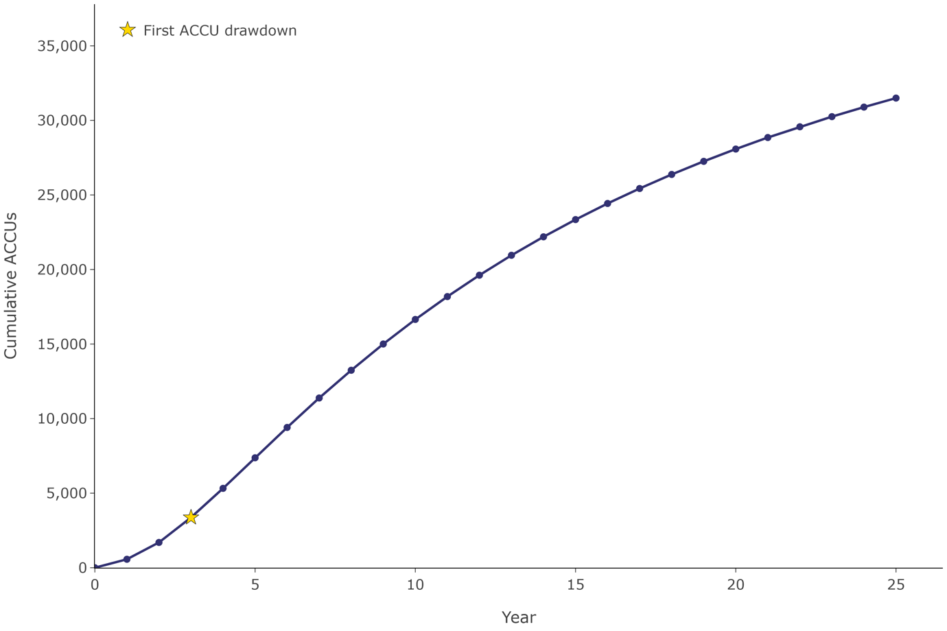

# Site information

## Slope

Slope is an important consideration for assessing EP carbon projects as it can directly influence future planting operations such as the operation of heavy machinery or by limiting accessibility. This section provides an overview of the topography of the specified project area.

Figure 3. Slope (degrees) at the Somewhere property

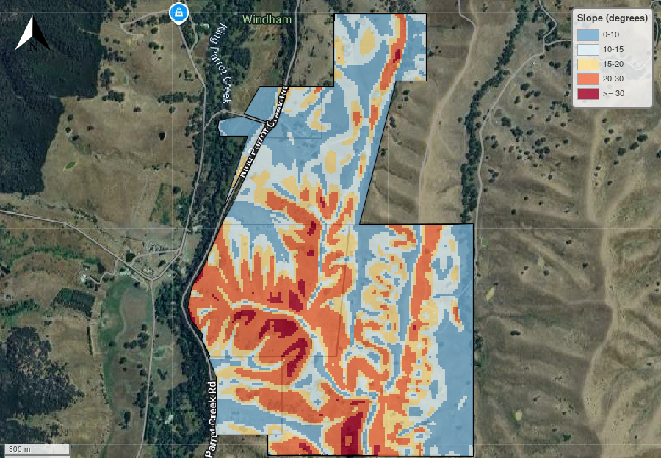

Table 4: Planting area defined by slope.

|  |  |  |
| --- | --- | --- |
| Slope (degrees) | Planting Area (ha) | Planting Area (%) |
| 0 - 10 | 46.51 | 28.14 |
| 10 - 15 | 38.28 | 23.16 |
| 15 - 20 | 32.59 | 19.71 |
| 20 - 30 | 43.63 | 26.39 |
| >= 30 | 4.30 | 2.60 |
| Total | 165.31 | 100.00 |

## Infrastructure

There’s lots of roads and buidlings

Figure . Infrastructure

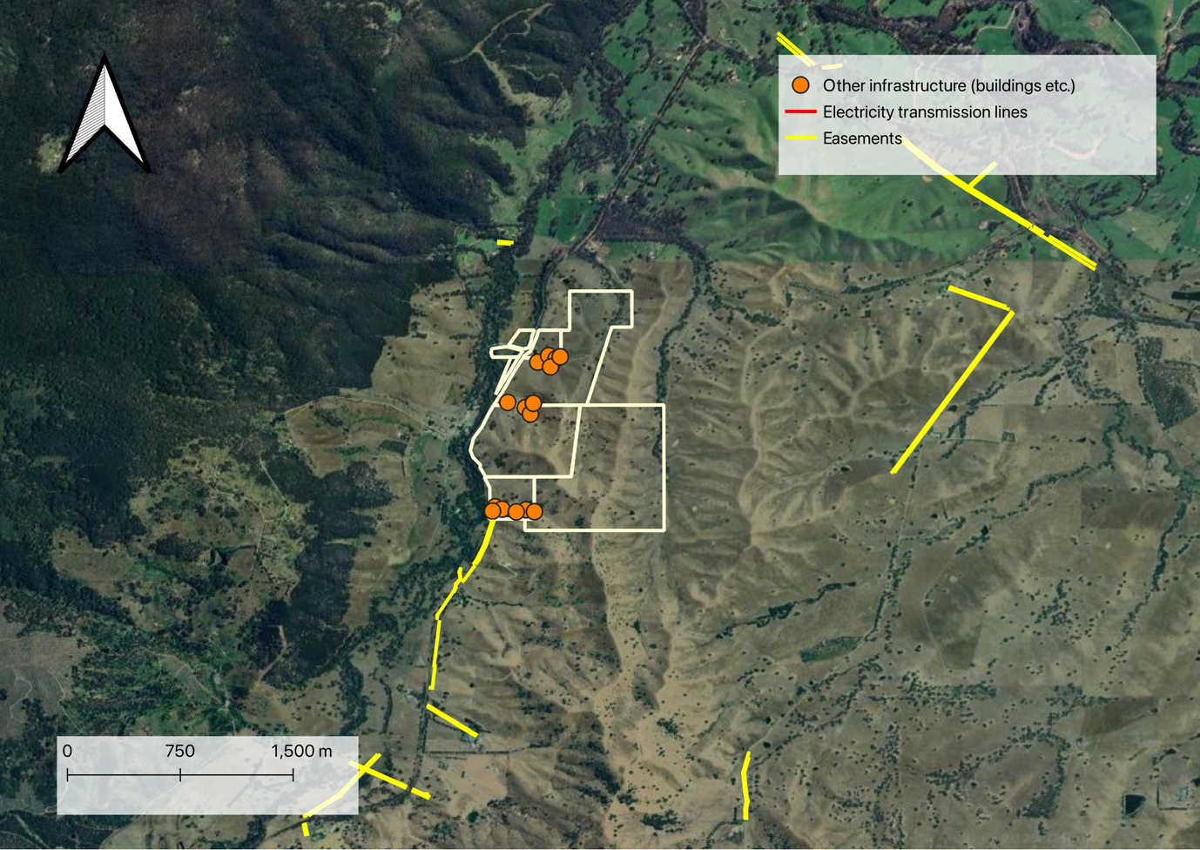

## Tenure

Land tenure

Figure . The tenure is Freehold with some conservation areas

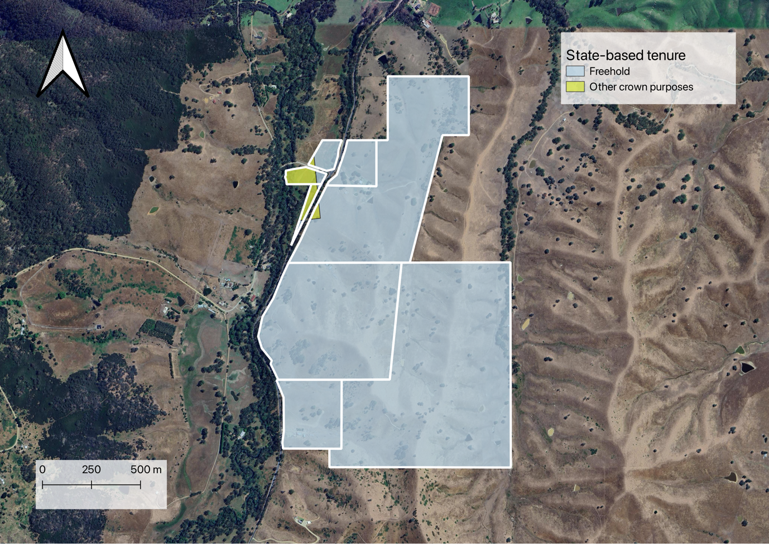

## Zoning

Land zoning

Figure . Zoning

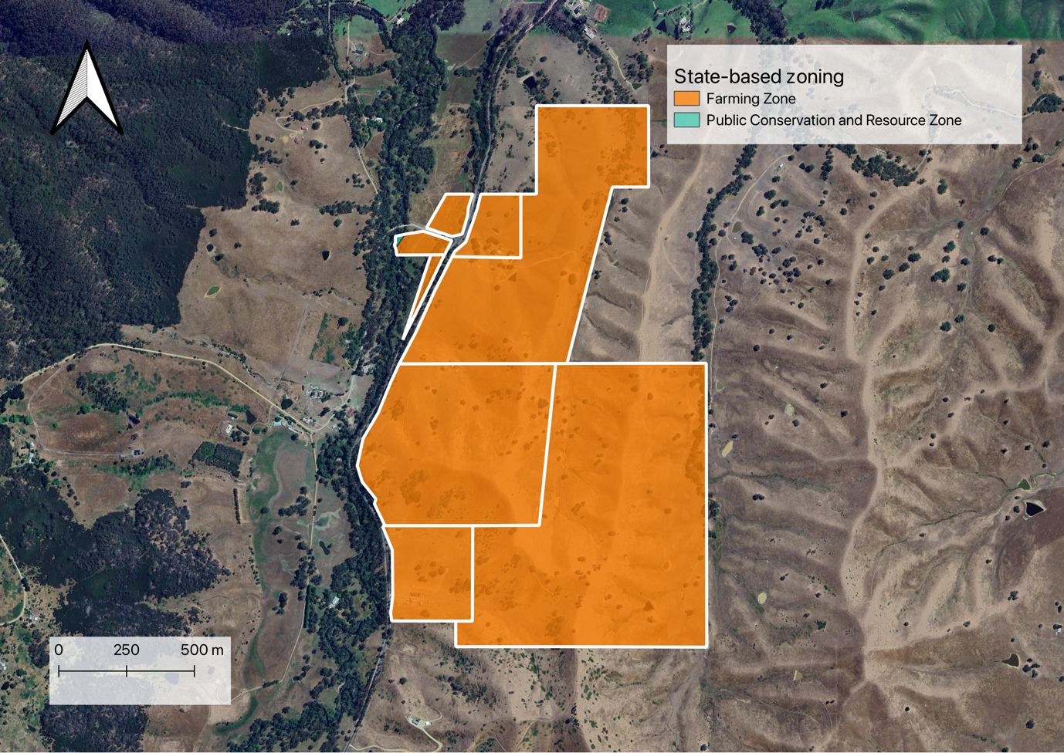

## Land titles

Any native titles or mining leases

Figure . Land title

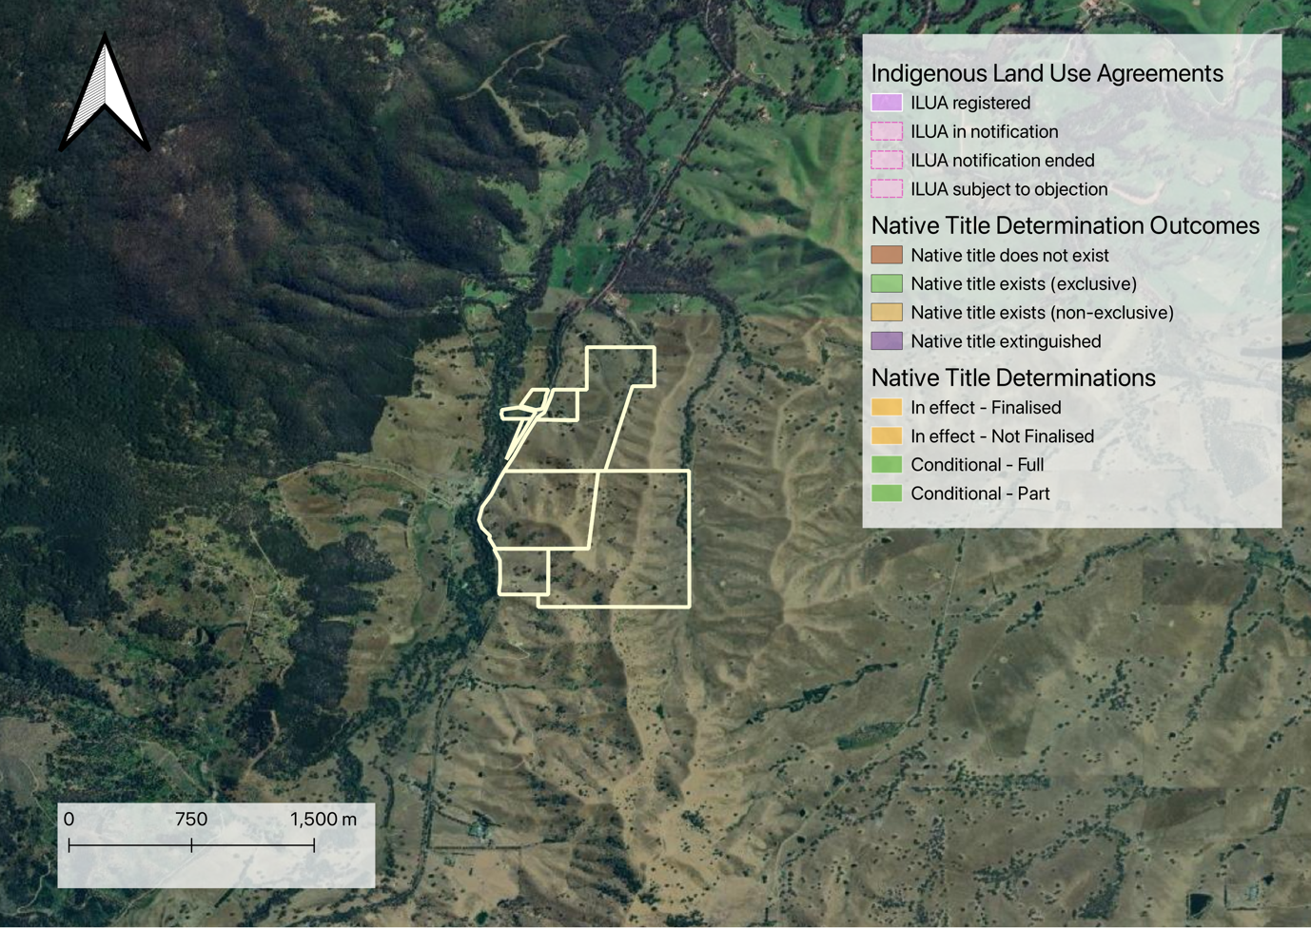

## Existing CER projects

Currently registered projects on your property

Figure . Existing CER registered projects

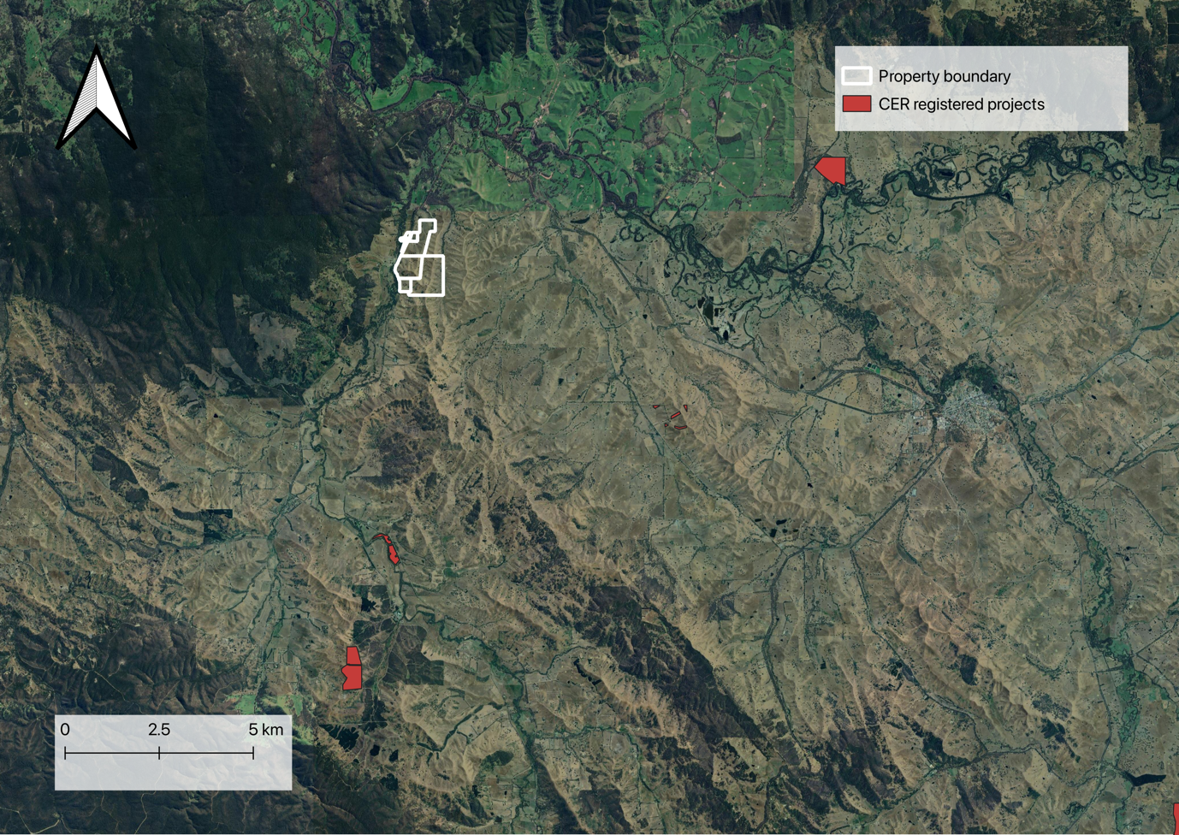

# Environmental

## Climate

Some historical climate data for your perusal

### Precipitation

I’m Precipitation

Figure . Precipitation

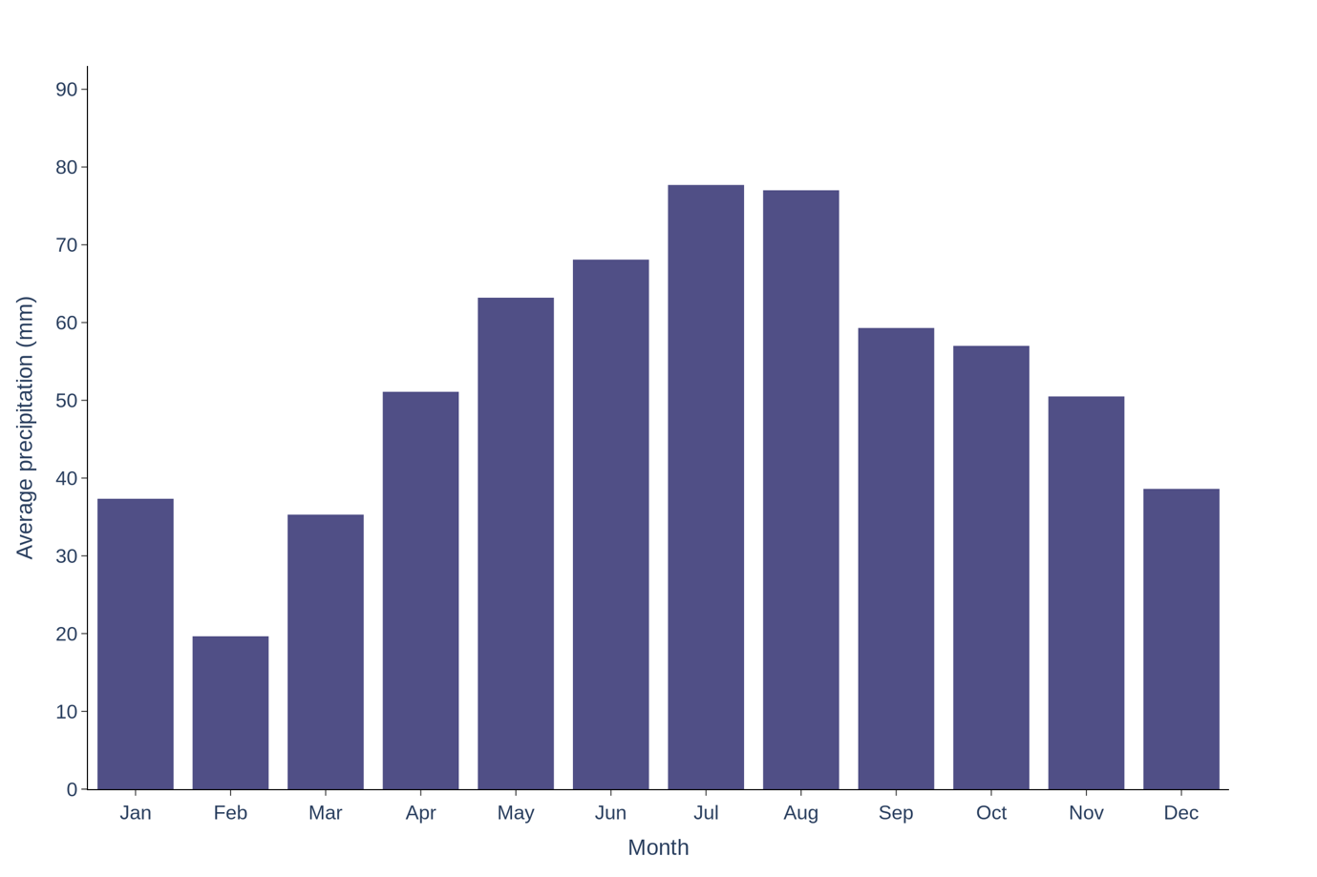

### Temperature

I’m temperature

Figure . Temperature

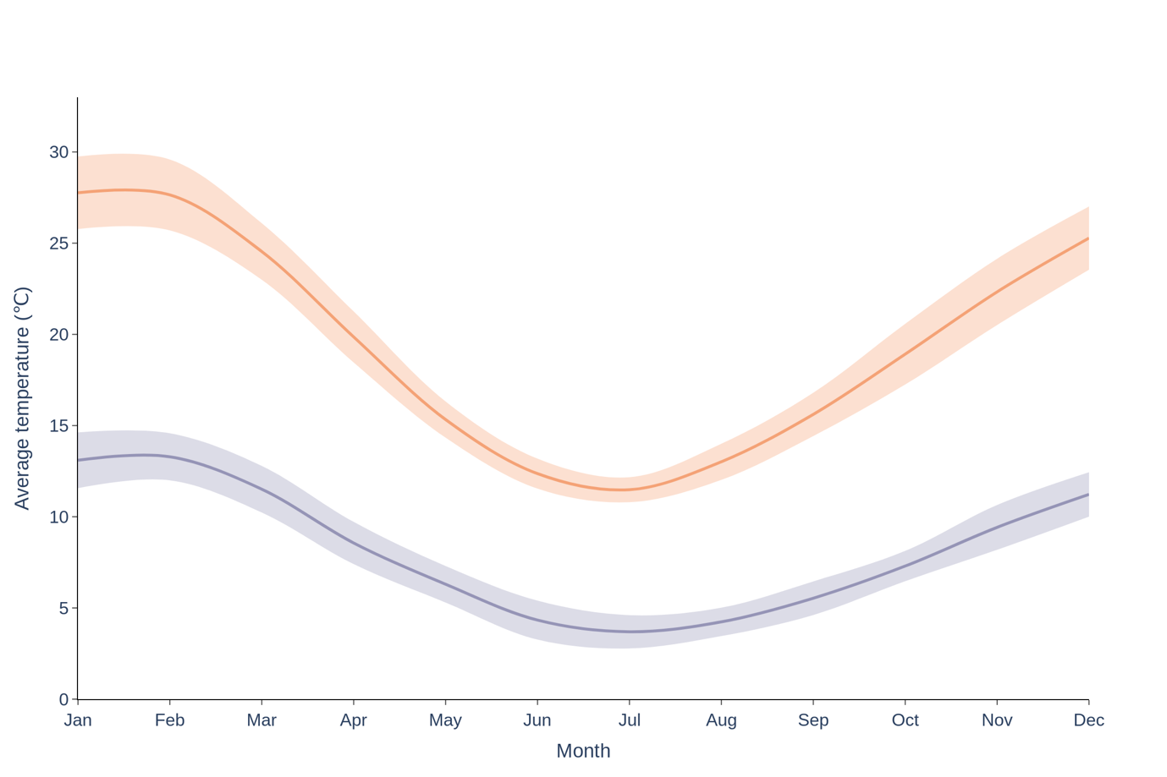

### Frost

Let’s talk about frost. X number of frost days per year

Figure . Frost

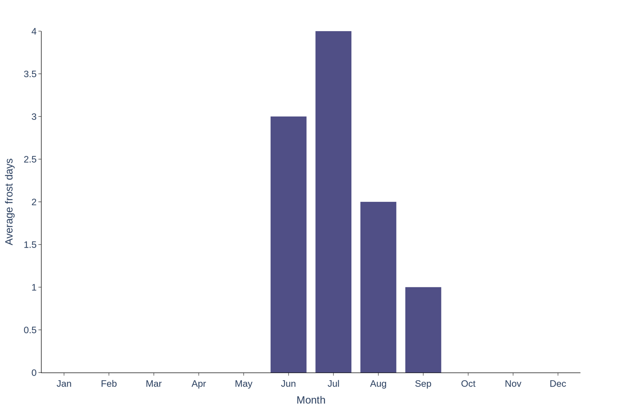

## Drought

There’s drought here

Figure . Drought

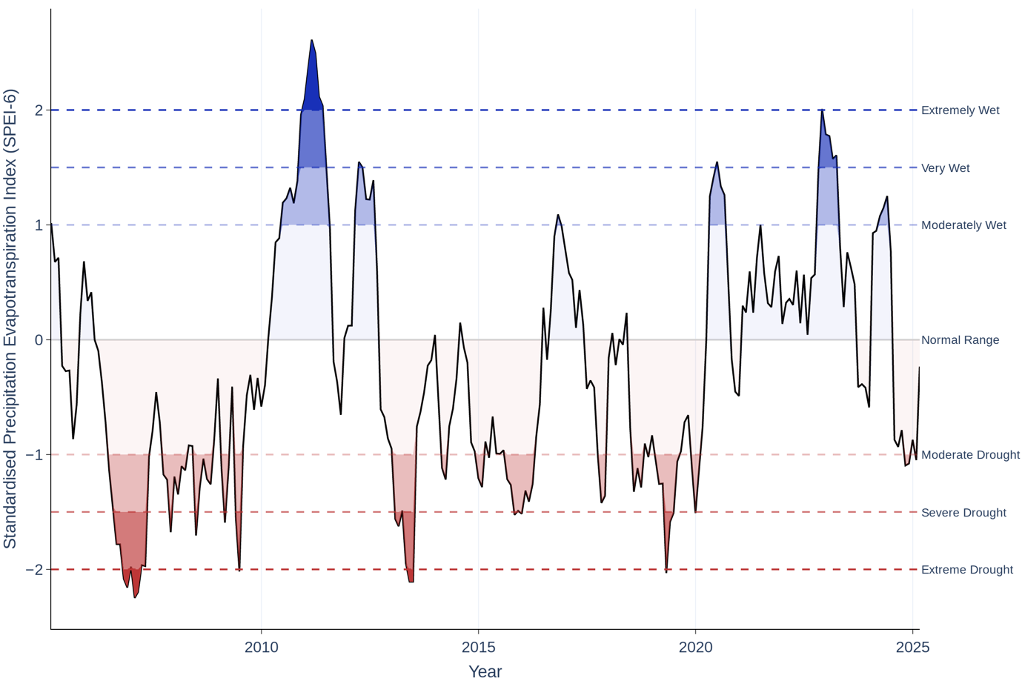

## Fire risk

There’s been some fires

Figure . Fires nearby

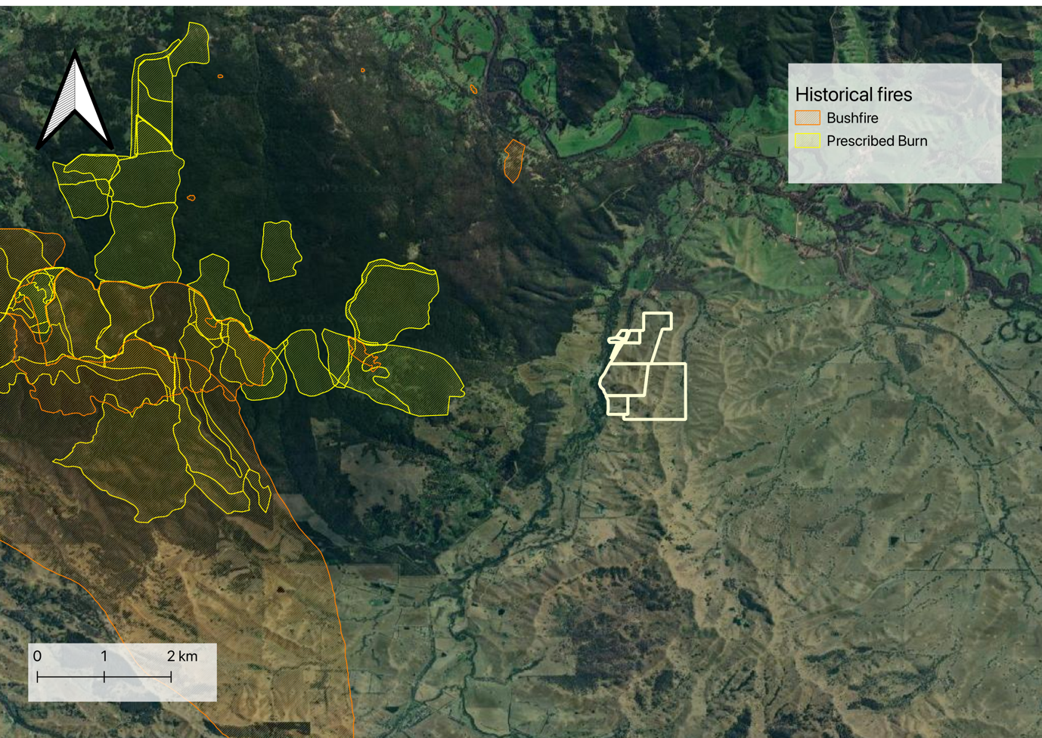

## Flood risk

What floods are doing here

Figure . Flood risk in the region

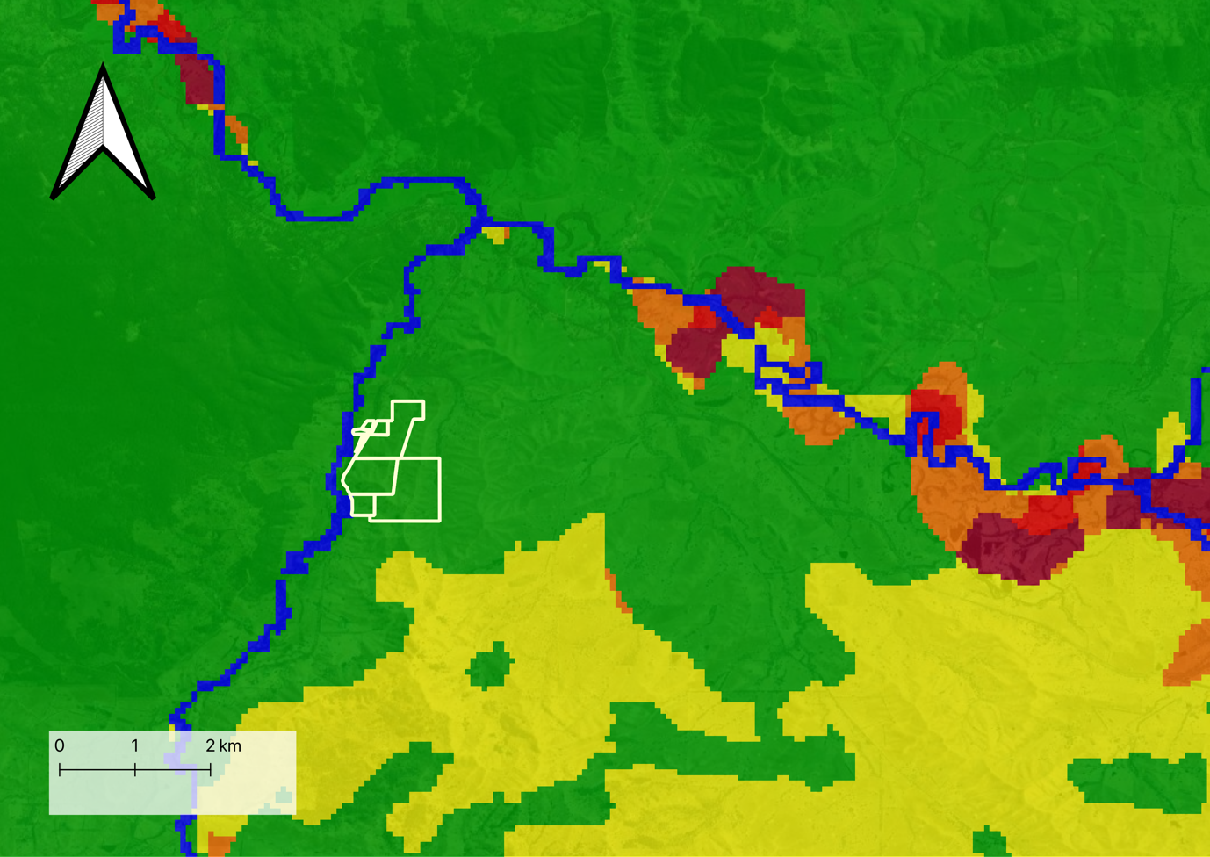

## Salinity

Salt is not good for most plants

### Dryland salinity

Yellow blobs of goodness

Figure . Areas deemed high risks of dryland salinity in the area

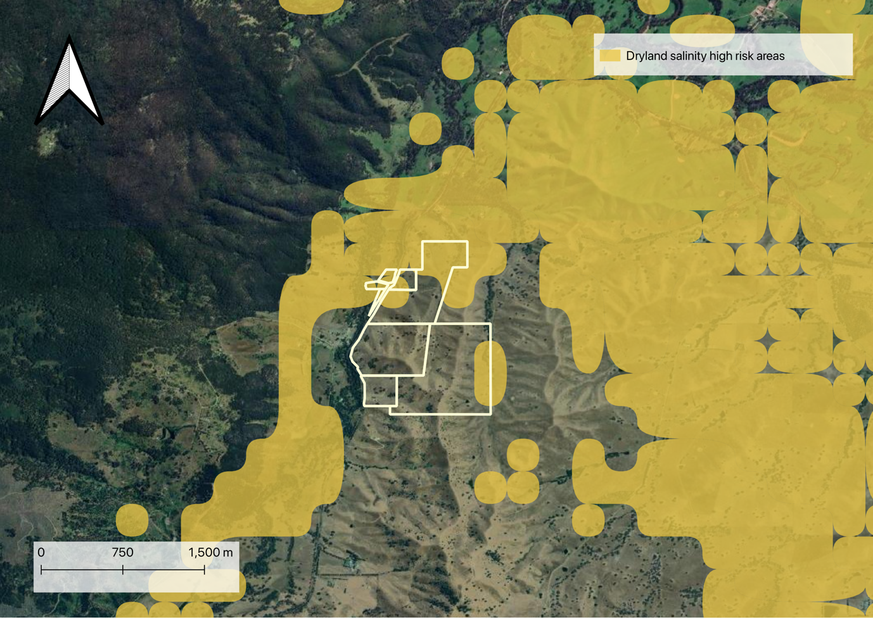

### Surface salinity

Data not available for this location.

# Biogeography

Spatial arrangement of biological bits and bobs.

## Soil

Here’s soil

Figure . State-based soil mapping

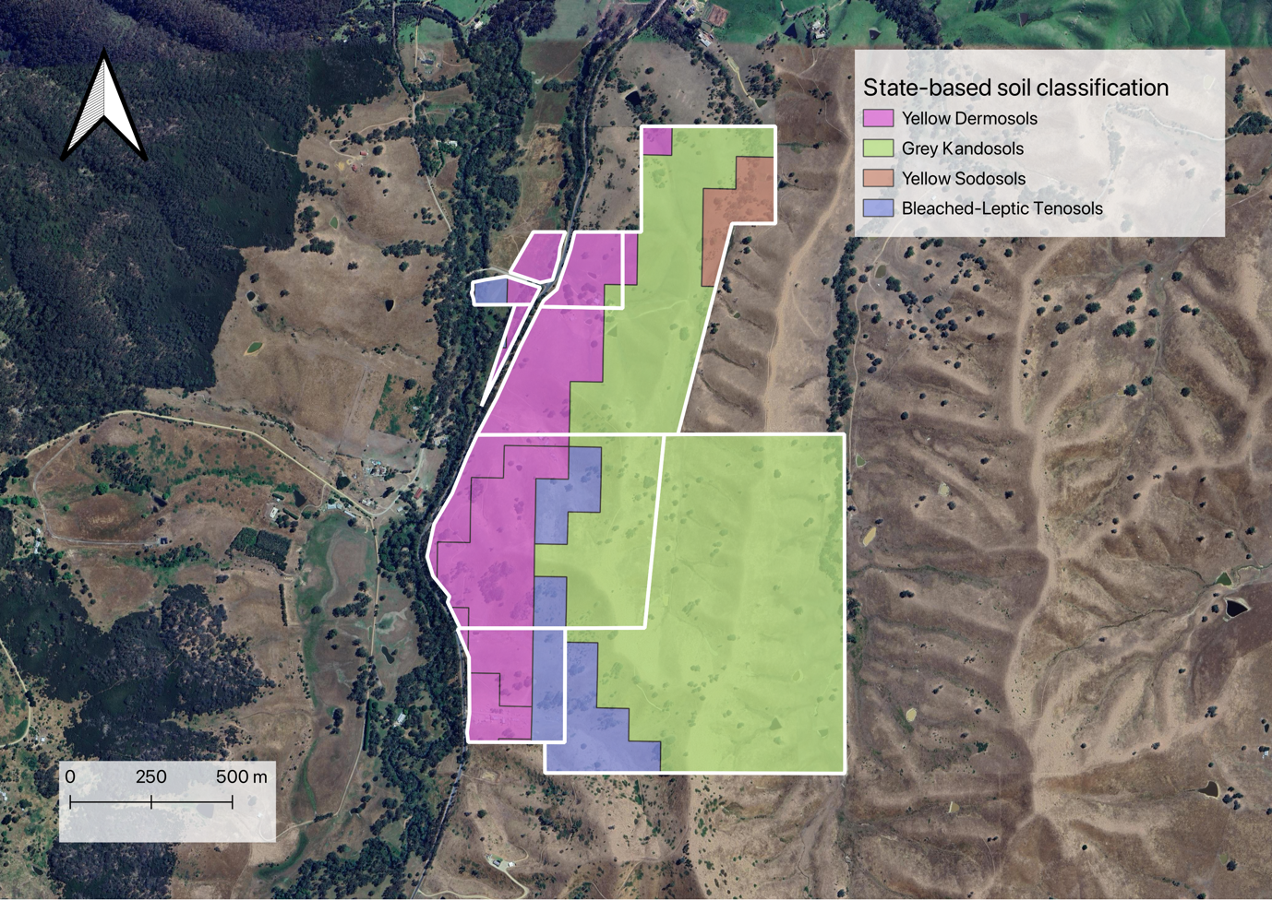

## Vegetation

Let’s talk about vegetation in the area.

### Major vegetation groups (pre-European settlement)

Major vegetation groups pre-European settlement in this area

Figure . Major Vegetation Groups (MVG)

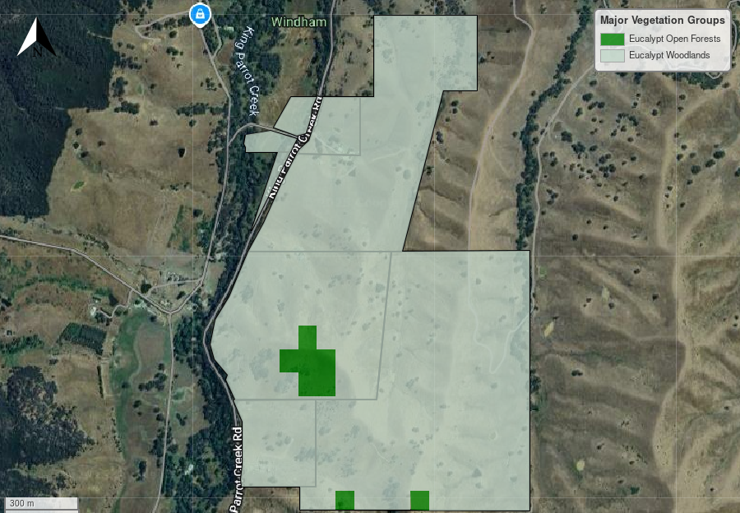

### Fine scale vegetation mapping (pre-European settlement)

Here’s what vegetation we expect to see and whether it is valid

Figure . Fine-scale pre-European vegetation mapping

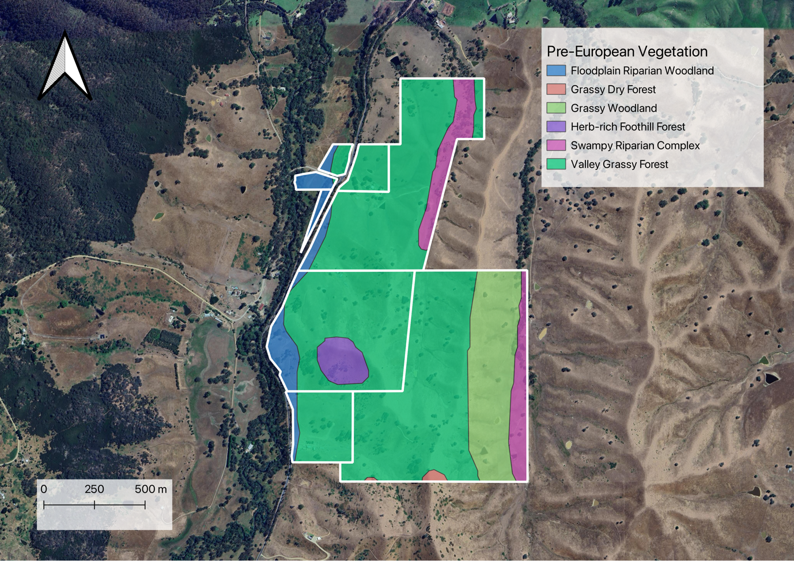

## Potential weeds

Some potential weeds to look for

Table . Table of weeds

|  |  |  |  |  |
| --- | --- | --- | --- | --- |
| **Common name** | **Scientific name** | **Growth form** | **WONS** | **Biosecurity duty (Goulburn Broken CMA)** |
| African boxthorn | Lycium ferocissimum | Shrub | Y | Regionally controlled |
| African daisy | Senecio pterophorus | Herb | N | Regionally prohibited |
| African feather grass | Cenchrus macrourus | Grass | N | Regionally prohibited |
| African lovegrass | Eragrostis curvula | Grass | N | Regionally controlled |
| Amsinckia | Amsinckia calycina | Herb | N | Regionally controlled |
| Artichoke thistle | Cynara cardunculus | Herb | N | Regionally prohibited |
| Blackberry | Rubus fruticosus | Shrub | Y | Regionally controlled |
| Boneseed | Chrysanthemoides monilifera | Shrub | Y | Regionally controlled |
| Buffalo burr | Solanum rostratum | Herb | N | Regionally controlled |
| Caltrop | Tribulus terrestris | Herb | N | Regionally controlled |
| Cape tulip (one-leaf) | Moraea flaccida | Herb | N | Regionally prohibited |
| Cape tulip (two-leaf) | Moraea miniata | Herb | N | Regionally prohibited |
| Chilean cestrum | Cestrum parqui | Shrub | N | Regionally controlled |
| Chilean needle grass | Nassella neesiana | Grass | Y | Restricted |
| Devil's claw (purple flower) | Proboscidea louisianica | Herb | N | Regionally controlled |
| Devil's claw (yellow flower) | Proboscidea fragrans | Herb | N | Regionally controlled |
| English broom | Cytisus scoparius | Shrub | Y | Regionally controlled |
| Flax-leaved broom | Genista linifolia | Shrub | Y | Restricted |
| Golden thistle | Scolymus hispanicus | Herb | N | Regionally controlled |
| Gorse | Ulex europaeus | Shrub | Y | Regionally controlled |
| Hardheads | Centaurea nigra | Herb | N | Regionally controlled |
| Illyrian thistle | Onopordum illyricum | Herb | N | Regionally prohibited |
| Khaki weed | Alternanthera pungens | Herb | N | Regionally controlled |
| Noogoora burr | Xanthium occidentale | Herb | N | Regionally controlled |
| Paterson’s curse | Echium plantagineum | Herb | N | Regionally controlled |
| Prairie ground cherry | Physalis hederifolia | Herb | N | Regionally controlled |
| Prickly pear (drooping) | Opuntia stricta | Shrub | Y | Restricted |
| Prickly pear (erect) | Opuntia elatior | Shrub | Y | Restricted |
| Ragwort | Jacobaea vulgaris | Herb | N | Regionally prohibited |
| Scotch thistle | Onopordum acanthium | Herb | N | Regionally controlled |
| Serrated tussock | Nassella trichotoma | Grass | Y | Regionally prohibited |
| Silverleaf nightshade | Solanum elaeagnifolium | Herb | Y | Regionally controlled |
| Skeleton weed | Chondrilla juncea | Herb | N | Restricted |
| Soldier thistle | Cirsium vulgare | Herb | N | Regionally controlled |
| Spiny broom | Calicotome spinosa | Shrub | N | Restricted |
| Spiny burr grass | Cenchrus longispinus | Grass | N | Regionally controlled |
| Spiny emex | Emex australis | Herb | N | Regionally controlled |
| Star thistle | Centaurea calcitrapa | Herb | N | Restricted |
| Stemless thistle | Cirsium acaule | Herb | N | Restricted |
| St Barnaby's thistle | Centaurea solstitialis | Herb | N | Restricted |
| Thorn apple (recurved) | Datura stramonium | Herb | N | Regionally controlled |
| Wheel cactus | Opuntia robusta | Shrub | Y | Restricted |

# Next steps

Where to next?

## Proposition

Good project. Let’s go

## Considerations

Let’s consider some things.

## Next steps

### What else is involved with an EP project?

Evaluating the feasibility of an EP project requires the analysis of additional factors that may influence project development. For example, environmental conditions such as soil type, vegetation classifications, long-term climatic conditions, and exposure to natural hazards can significantly influence the overall viability of developing a biodiverse planting and ultimately determines whether a property is suitable to progress.

Project proponents[2] are also required to assess additional risks such as whether there is a legal right to develop a project by considering variables such as land tenure, zoning, native title claims and how regional and local strategic plans may impede project establishment.

It is also beneficial for project proponents to have a high degree of confidence that the carbon sequestration potential of a project is accurate. For EP carbon projects, this requires a method-compliant workflow of project stratification, followed by modelling the projects potential ACCU generation through the Full Carbon Accounting Model (FullCAM) software5.

After a desktop assessment, a site visit is highly recommended as it offers the opportunity to ground-truth the information gathered in this report and to also reassess how these variables meet (or do not meet) project eligibility requirements. For example, information from a site visit will likely inform the recalculation of the potential ACCUs generated from a project by refining the planting and exclusion areas.

If a project is deemed feasible and worth developing further, the next steps are summarised in Figure 2 below:

Figure . A timeline outlining the key stages of a carbon project, from initial desktop assessment and site visits to CER project registration and ongoing monitoring, reporting, and verification post-planting.

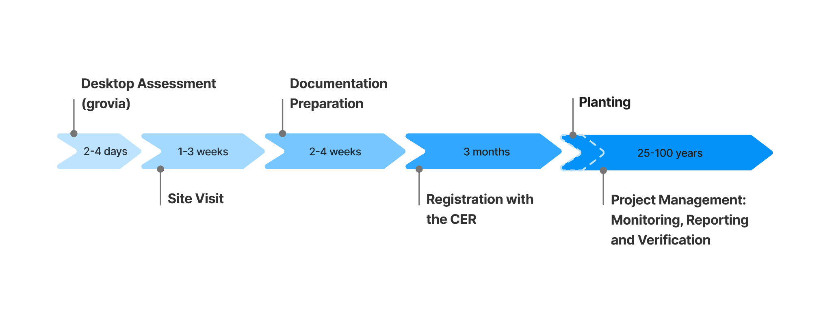

### Proceeding with project

The grovia platform is designed to help you streamline the steps outlined in figure 5; from further assessing the feasibility of a project with site visit data, to optimising planting efforts and fine-scale tracking of project success with our measurement, reporting, and verification (MRV) data management module.

As a next step, chatting to the team about refining your planting area based on a site visit.

Our expert team will work with you to understand all your project goals and ensure the project is delivered to a high standard and with integrity. If you would like to request a report, or have any questions, please get in touch *contact@grovia.earth*. 

1. Environmental Planting carbon projects cannot be developed on land that contains or needs clearing of woody biomass. If land clearing has occurred, the clearing event must have occurred at least 5 years prior to project application or seven years if property has undergone no recent change in ownership. The grovia platform assesses for evidence of land clearing within the last 7 years and areas with identified ‘forest loss’ is classified as ‘ineligible’ for project development. Areas that have existing woody biomass are omitted from the planting area.
2. A project proponent is the party who has the legal right to develop a project and is responsible for carrying out the project, is issued credits for the project and is legally responsible for meeting all obligations under the law. See <https://cer.gov.au/schemes/australian-carbon-credit-unit-scheme/how-to-participate/plan-your-project/choose-project-proponent> for more information.

   5 <https://www.dcceew.gov.au/climate-change/publications/full-carbon-accounting-model-fullcam>